**Titanic Dataset Analysis**

**EXECUTIVE**:

It is the analysis of the data about all the passengers that were travelling the Titanic in order to determine the factors that contributed in saving the lives of the survived passenger. What we learnt from this analysis is that the age, gender, passenger class and port of embarkment greatly contributed to the passenger’s survival.

**INTRODUCTION AND PURPOSES**:

This data analysis report using R language highlights the verification of the data consistency, bar plots of the variables, Conversion of categorical data into numeric data and validation of the statistical analysis.

The analysis was conducted by Suven Consultants and Technology Pvt. Ltd. for an online internship corresponding to the course of “Data Analytics Using R”.

The analyser of this dataset is Aahan Gupta.

**LIMITATIONS**:

This analysis has got certain limitations:

* Accuracy percent of the prediction model for this dataset is less.
* Analysis cannot be automated using R language.

**METHODS**:

* **Verification of data consistency:**

Checking and omitting the NA and blank values.

* **Bar Plotting:**

Generic bar plotting of input variables.

* **Conversion of data:**

Converting the categorical data into numeric values.

* **Validation of the statistical analysis:**

Validating the statistical data.

**SAMPLE**:

The personal who contributed to the analysis are as follows:

* **Niraj Sharma**: Instructor at SCTPL, taught how to use R language for data analysis.
* **Aahan Gupta**: Student at SCTPL, taught by Niraj Sharma, Made the full analysis on the Titanic Dataset along with this report with the help of Ashish Gupta and Niraj Sharma.
* **Ashish Gupta**: Father of Aahan Gupta, who helped Aahan Gupta in making this report.

**INSTRUMENTATION**:

The tools used by us are as follows:

* Rstudio IDE
* R V3.5.1
* Sublime Text Editor

**RESULTS**:

Following are the findings after the analysis has been done:

* The number of passengers travelling that belong to Class 1 are 216, Class 2 are 184 and Class 3 are 491.
* There were 314 females and 577 males travelling on the ship in total.
* There are records present where age is less than 1 and the age value for such records is fractional.
* 168 passengers embarked their journey from Cherbourg, 77 embarked their journey from Queenstown, 644 embarked their journey from Southampton.
* 342 passengers survived and 549 did not make it out alive.

Below are the findings using statistical analysis.

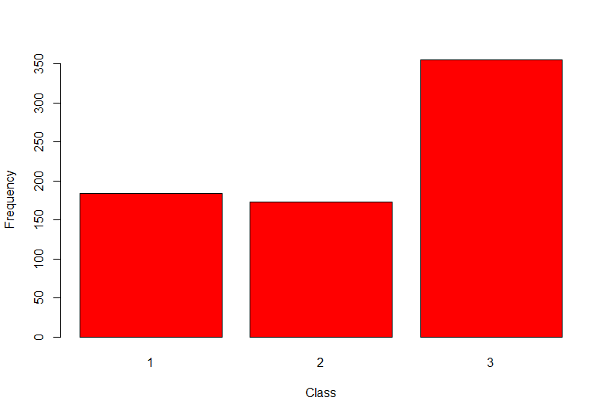

According to the above bar plot we find that majority of the passengers are from Class 3.

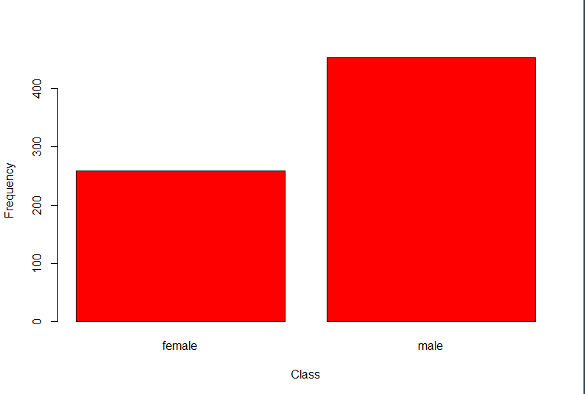

As we can see in the above plot, Number of males is higher than females.

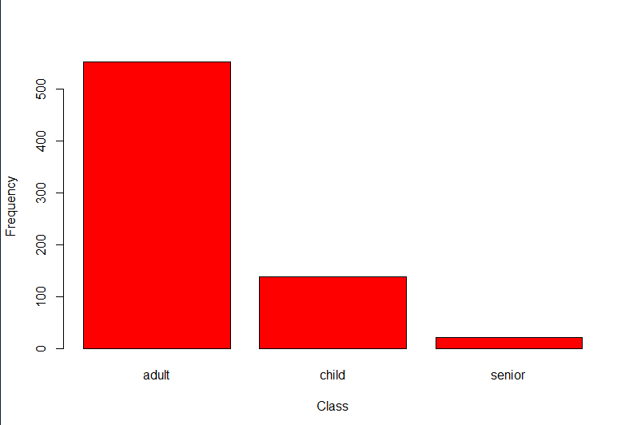

Here we find that majority of the passengers are adults.

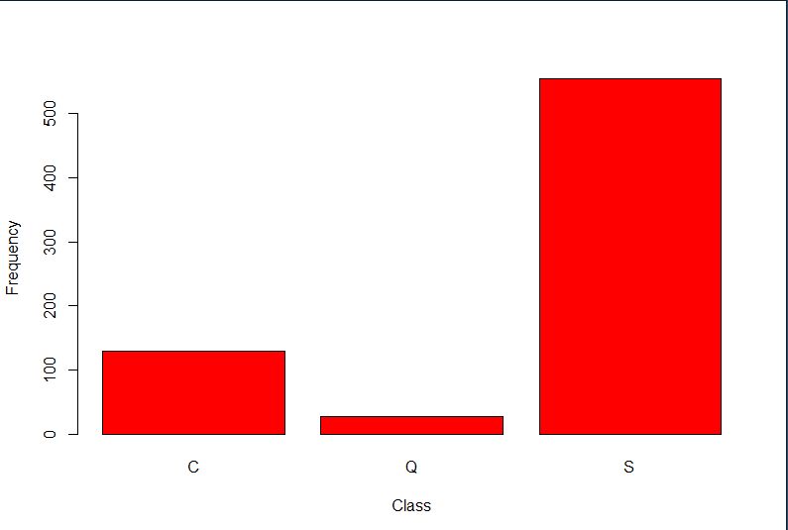

Here we can see that majority of the passengers embarked their journey from Southampton.

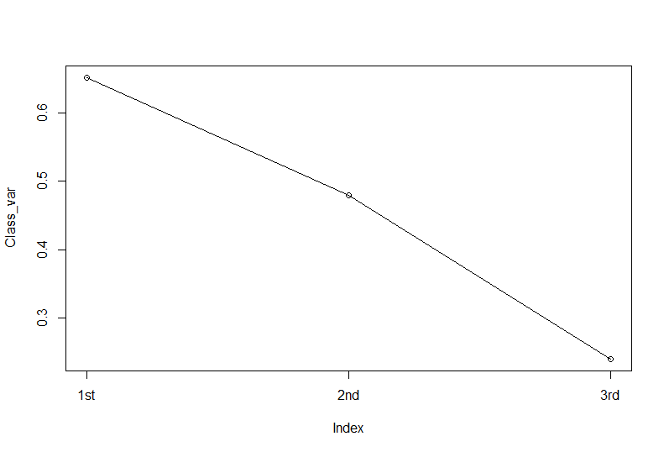

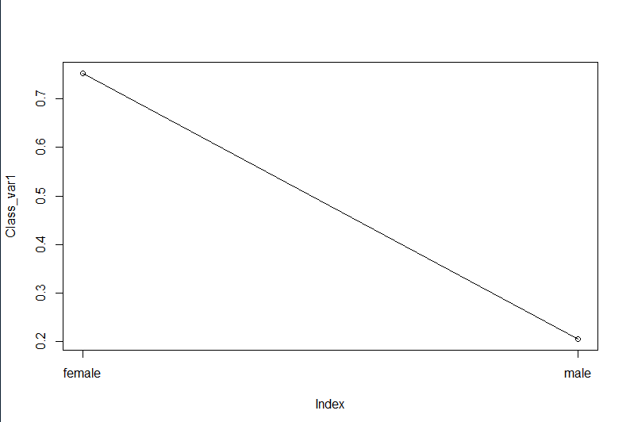

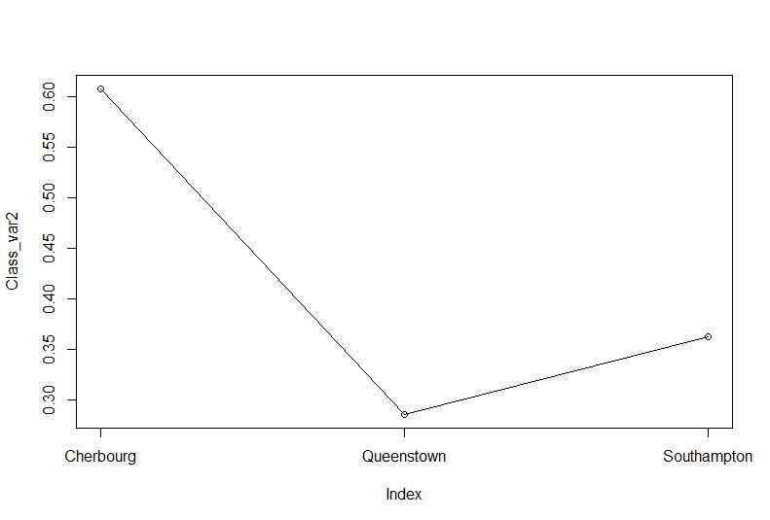

The highest average number of survivors belong to Class 1, female gender and port of embarkment Cherbourg.

We validated our scatter plots using anova function (1-way interaction) and below is the findings:

There is a statistically significance of 95% or above for the relation between the death of the person and their passenger class, gender, age and port of embarkment.

**RECOMMENDATIONS**:

This is just a practice analysis and no real-life recommendations may not be possible.

**SUMMARY**:

We performed analysis of survivors in the ship which sank in the North Atlantic Ocean. We performed a statistical analysis of the fatalities on the ship using the Titanic dataset. Our findings from this analysis is that there is a statistically significance of 95% or above for the relation between the death of the person and their passenger class, gender, age and port of embarkment.

**REFERENCES**:

<https://www.analyticsvidhya.com/>

<https://www.r-bloggers.com/>

<https://www.tutorialspoint.com/index.htm>

Notes provided by SCTPL.